

**NEW ZEALAND MARITIME SCHOOL**

**NZ Diploma Electro-technology**

**Year 1 ETO Cadets, 2019.**

**NZ2511-02.**

**(STCW-78 III/1, as amended in 2010)**

**Course 942.466**

**‘Safe Use of Electrical Equipment’**

**Learning Outcomes Assessment**

***Research each of the FOUR Learning Outcomes and answer with your interpretation.***

***You may work individually or as a team but you must name the team members.***

***Use reading material provided on Canvas, library material or other suitable sources. Where possible provide reference to the sources. Email back to the tutor when complete.***

**Tutor**: Nick Cossar

[nick.cossar@manukau.ac.nz](mailto:nick.cossar@manukau.ac.nz)

john.lamb@manukau.ac.nz

Student Name: Levi Shane Dubbelman

Student ID: 190000929

Team Members:

Date: 19th of February 2019

Learning Outcome 1: Follow safety instructions of electrical equipment and machinery

* Describe the transmission and distribution of electrical power.
* Describe the use and purpose of implementation of a "three phase-three wire, insulated neutral system" for shipboard application.
* Demonstrate basic knowledge of structure of electrical switchboards.
* Identify safety precautions before commencing work or repair.

On the vast majority of ships active today, electrical power comes in two primary categories of voltages. These are low voltage electrical power (Anything less than 1000 Volts) and high voltage electrical power (Anything greater than 1000 Volts). The majority of ships active today rely on three-phase alternating current electrical power. In addition, it is N.A.T.O. (North Atlantic Treaty Organization) convention to use an alternating current frequency of 60 Hz. Interestingly, ships of the Soviet Union relied on a 50 Hz frequency, and were unmistakeable by their unique radar patterns during the Cold War. It is this military origin, as well as the forerunner of the electrification of vessels, the United States, using 60 Hz on shore-based applications. Unlike in airplane engines, however, which use 400 Hz to minimize the weight of the vessel, it is more convenient to use a standardized alternating current frequency between shore and ship to allow a connection to shore power when docked without a costly rectifier-inverted setup.

Shipboard electrical systems transmit power from their main alternators onto large bus bars, connected to a primary switchboard. Depending on the size of the ship, there may also be a secondary or tertiary bus bar and switchboard connected to the main switchboard via bus ties. Generally speaking, these additional bus bars are connected to their own supplementary generators, so in the event of a critical power failure, the ship is still able to generate and consume electrical power. In some situations, it may even have enough electrical power generation to provide propulsion. Another advantage of this system of redundancies is the ability to micro-manage power generation to suit the requirements of the existing load, which maximizes fuel efficiency. In addition, under the S.O.L.A.S. (Safety Of Life At Sea) convention, vessels are required to house an emergency generator, which is also connected to an emergency switchboard. This emergency switchboard is connected to the primary switchboard via normally closed bus ties, and runs critical loads associated with ensuring the survival of passengers and crew. An example of a critical load is the shipboard lighting in areas like the engine room.

Lower voltage electrical power is achieved for specific purposes by step-down transformers. Once stepped down, electrical power can be provided to systems such as lighting at voltages similar to those found on shore. On passenger vessels, AC power can be provided in the form of sockets with which passengers can connect their devices from home, i.e. laptops, hairdryers. The majority of ships also include a battery array, for which the alternating current must be rectified by a series of diodes and capacitors into direct current, in order to charge the battery array. This battery array can be used for a number of systems, for example, the starter motor on the emergency generator.

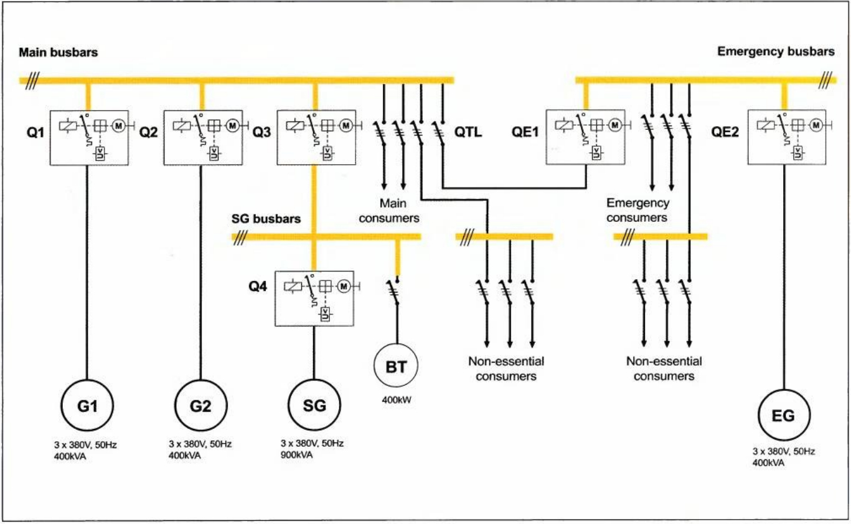

*Figure 1.1 Page 1 Chapter 1.1 - 3rd Edition Practical Marine Electrical Knowledge - Dennis T. Hall*

In the majority of shipboard electrical systems, an insulated neutral system is used. As mentioned previously, this system is three-wire three-phase alternating current. There are multiple advantages to this system. The primary advantage is redundancy. When a connection to earth (the ship’s hull), otherwise known as an earth fault, is made by one wire, perhaps exposed by the rigorous wear and tear sustained by all shipboard equipment, instead of making a short circuit and instantly tripping the circuit breaker, which in some applications could potentially result in an unsafe situation (e.g. a lack of lighting, or navigation). However, with the insulated distribution system, the equipment continues to operate normally because there is no complete circuit for current to flow. Though, if a second earth fault occurs on another line in the insulated system, a short circuit will occur and trip the circuit breaker, thus disconnecting the devices and potentially creating a risk to the safety of the ship and her crew and passengers.

Onboard ships, an electrician has a power set of tools available to their use in maintenance and monitoring, as well as assisting in ensuring safety of crew and protection from electrocution. In a standard switchboard, for example, there exists an overcurrent trip device to protect against short circuits, arc chutes to reduce the effect of discharging arcs when the breaker is tripped. On high voltage systems, generally these circuit breakers are contained in a vacuum or gas-filled insulator casings.

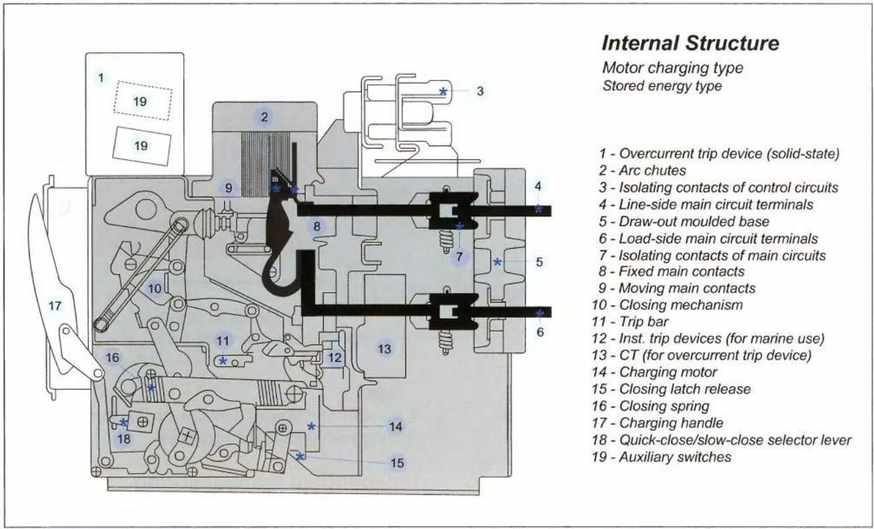

*Figure 3.19 Page 69 Chapter 3.1 - 3rd Edition Practical Marine Electrical Knowledge - Dennis T. Hall*

In addition, for monitoring, generator main switchboards have a

Learning Outcome 2: Recognise and report electrical hazards and unsafe equipment

* Recognise safety hazards which can be present when working on shipboard electrical equipment: electric shock, arc blast, transient overvoltage, and moveable (rotating) parts, environmental factors like high temperature, humidity, water, fuel, steam leaks, rain, wind, and ship rolling or pitching.
* Follow isolation and emergency procedures.
* Explain Lockout/Tag out procedures.

Answer here

Learning Outcome 3: Understand safe voltages for hand-held equipment

* Recognise causes of electric shock and precautions to be observed to prevent shock.
* Describe relationships between shock voltage and shock current.
* Recognise the possibility of the electric shock by the electrostatic charge.
* Explain the influence of shock current on human body.
* Recognise meaning of warning signs.

Answer here

Learning Outcome 4: Understand risks associated with high-voltage equipment and on-board work

* Explain the different voltages on-board and their risks.
* Explain the difference of electric shock caused by low and high voltage.
* Explain the basic parameters of electric arc: the temperature, the energy etc.
* Demonstrate basic understanding of general High Voltage protection measures: housings, partitions, distances, insulation mats, insulation materials, access restrictions, markings and warnings, HV equipment access monitoring and locks.

Answer here